- Deploy Services to Azure Container Apps
  - Screenshots of the configuration process for each Container App instance (PetStoreApp, PetService, ProductService, OrderService) on the "Basics", "Container", and "Ingress" tabs.
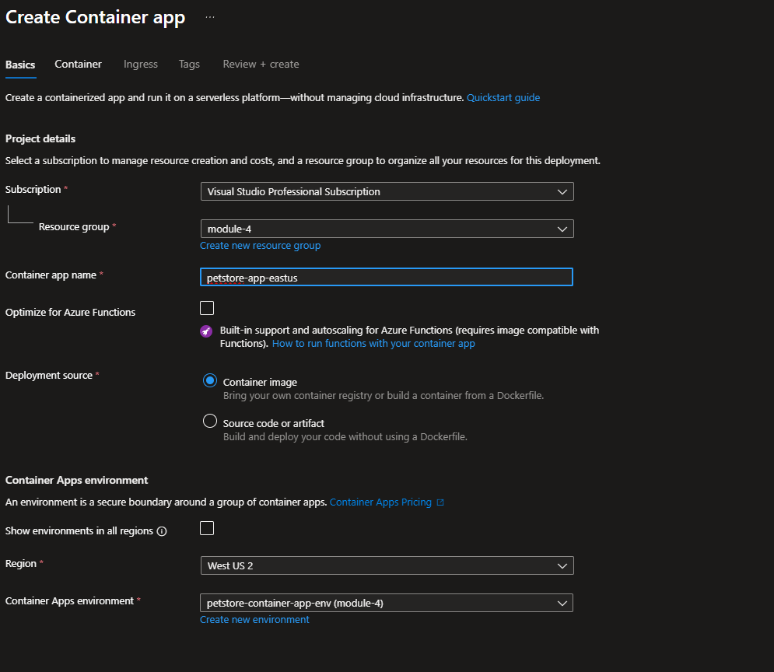
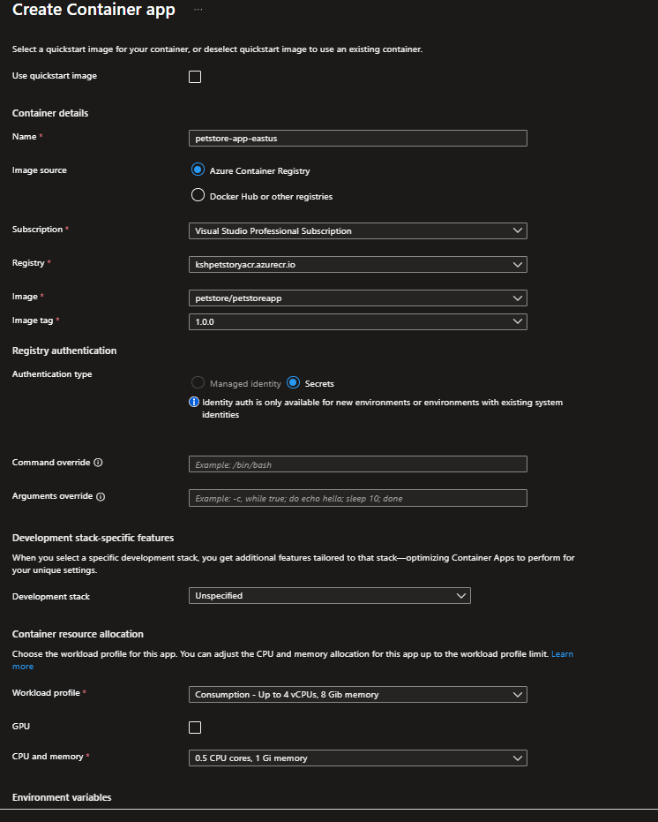
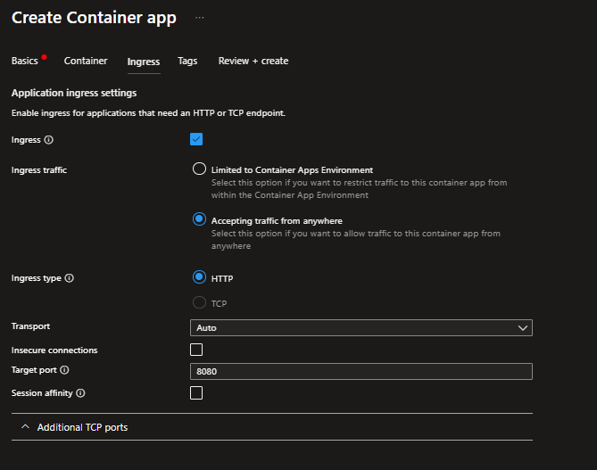

  - Screenshot showing the successful creation of each Container App instance.
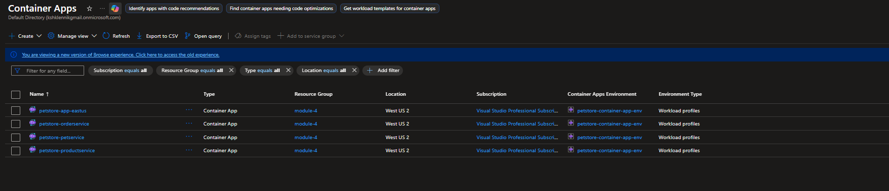
- Configure Environment Variables
  - Screenshots of the Application URLs from the "Overview" tab.
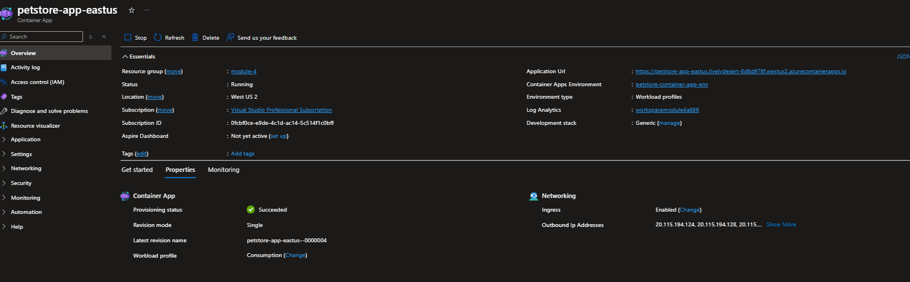
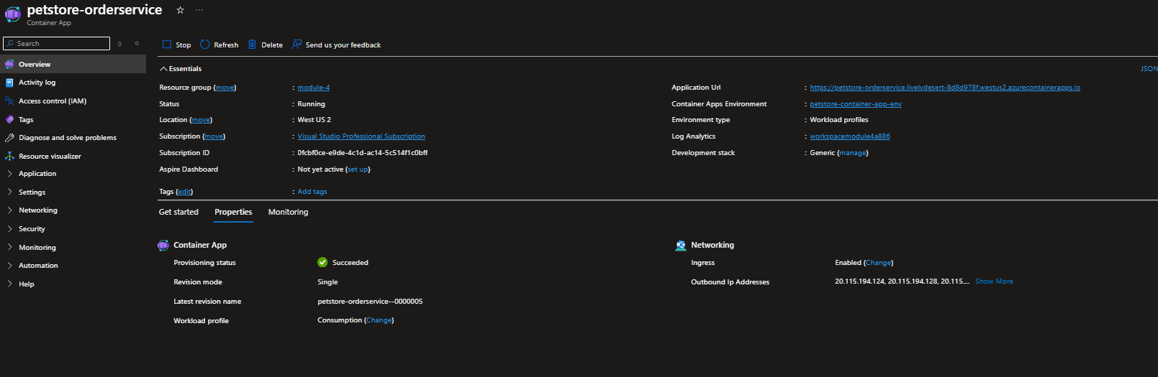
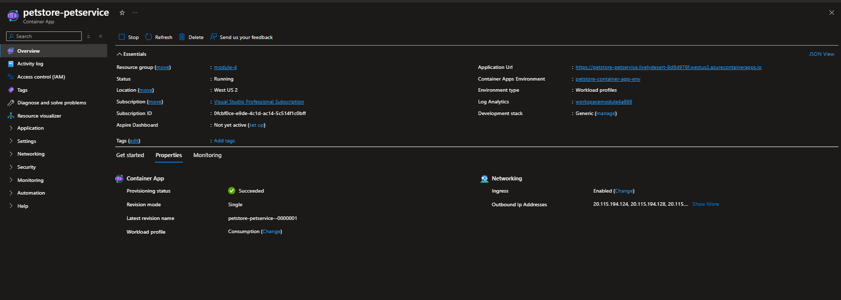
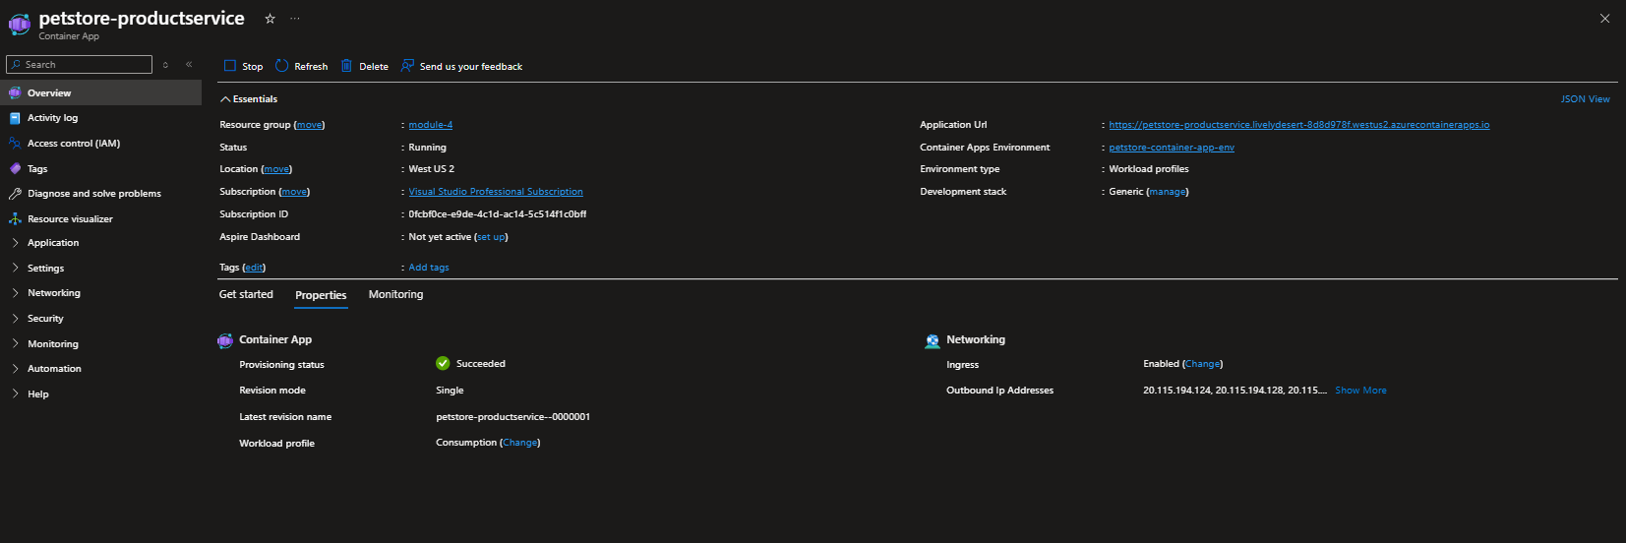
  - Screenshots showing the process of adding environment variables in the "Environment Variables" section.
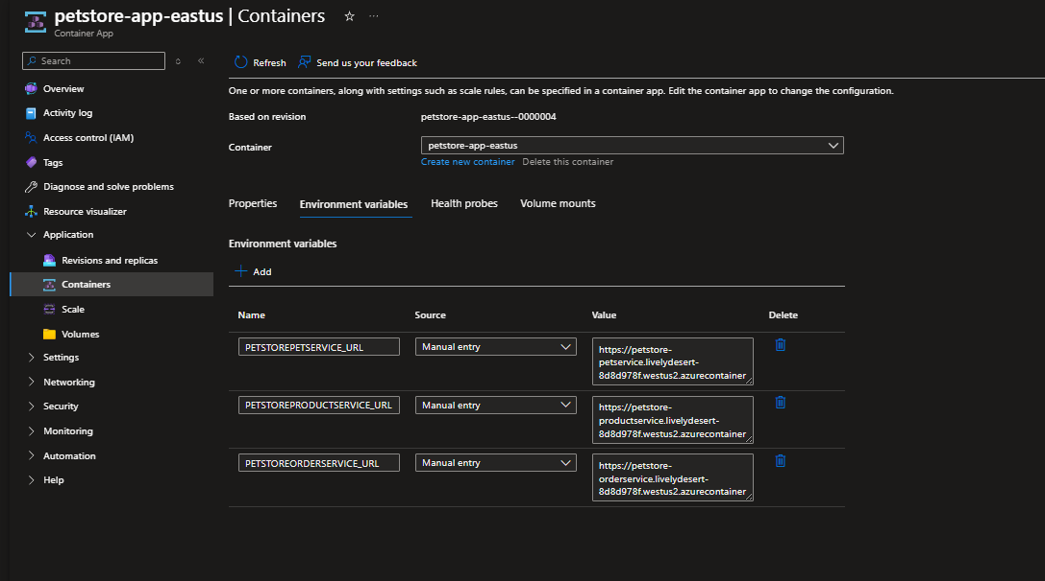
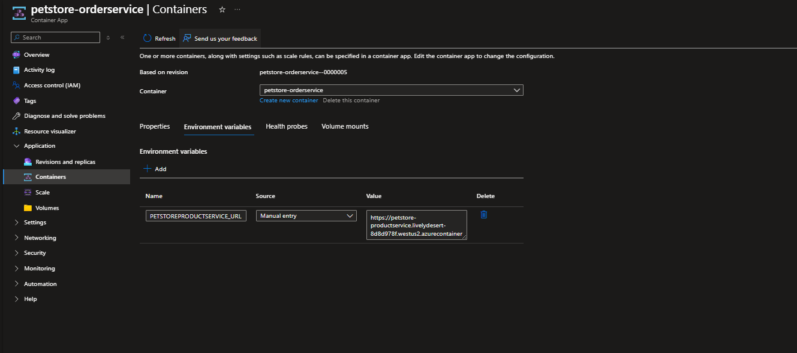
- Configure Autoscaling
  - Screenshots of the "Scale and replicas" settings for each Container App (PetStoreApp, PetService, ProductService, OrderService).
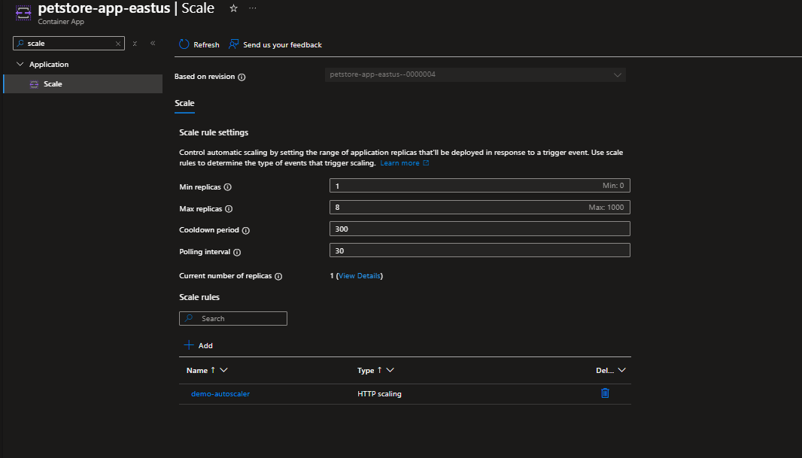
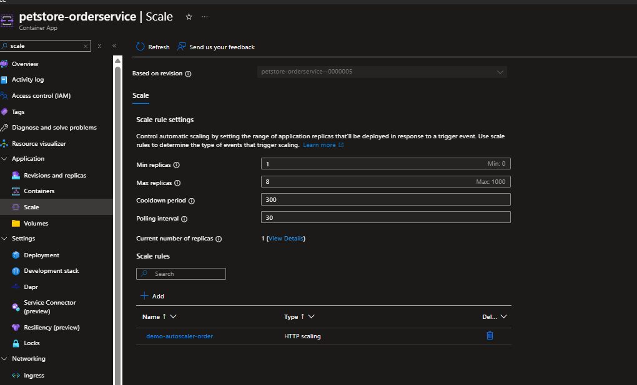
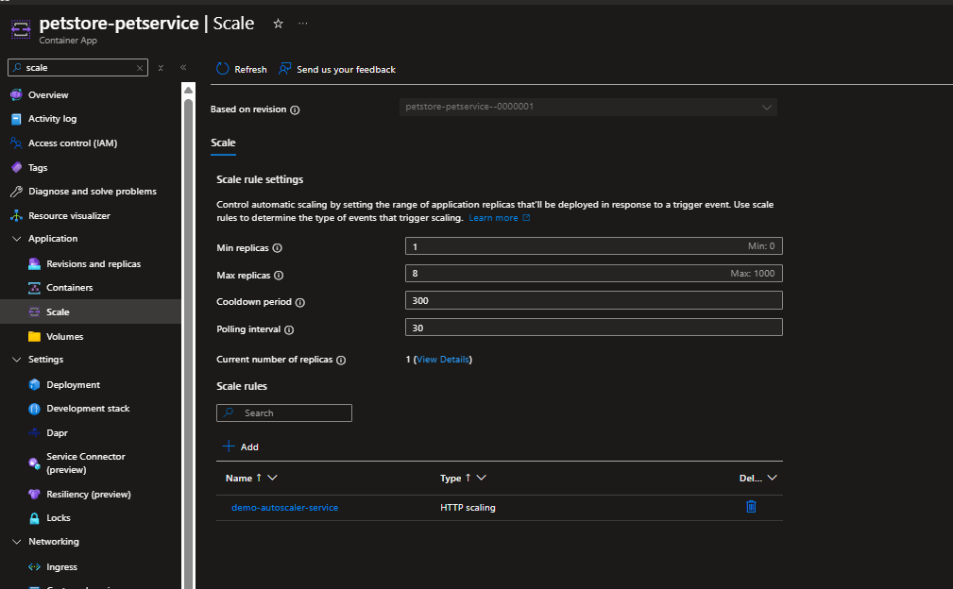
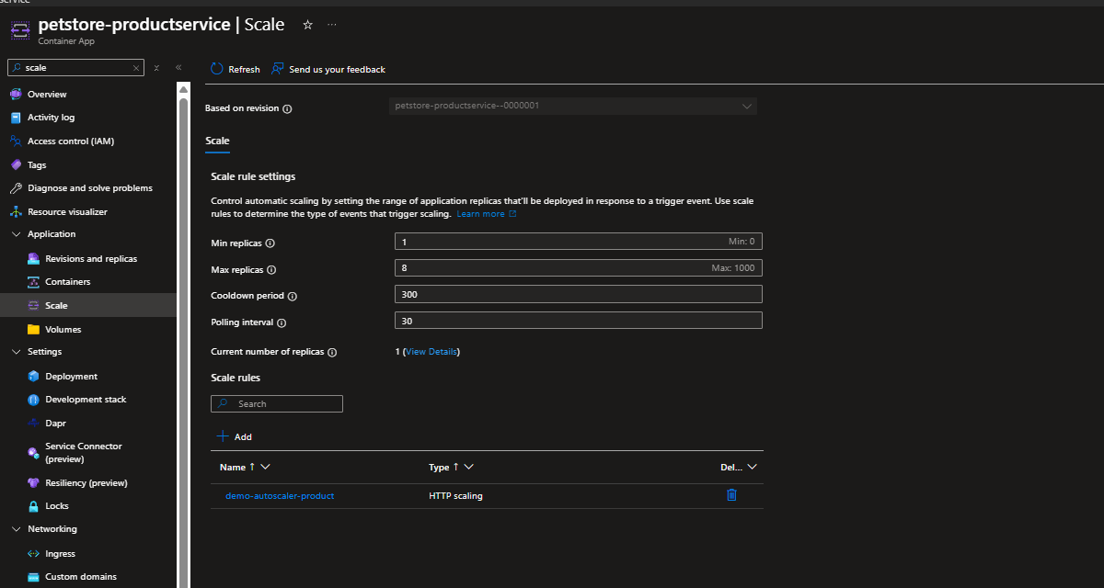
  - Screenshots of the "Add scale rule" configuration for HTTP scaling and concurrent requests settings.
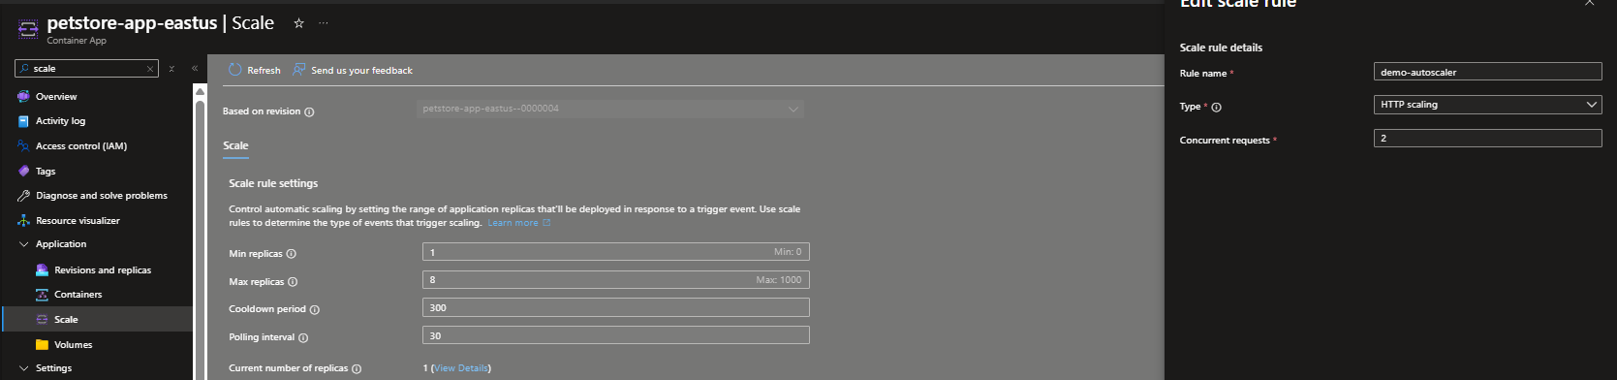
- Test Autoscaling using k6 Tool
  - Screenshots of Swagger endpoints utilized for testing autoscaling.
  - Screenshots of the k6 tool in use for testing autoscaling.
  - Screenshots of the results, particularly showing the scaling behavior under load.
- Deploy Multiple Revisions Simultaneously for PetStoreApp
  - Screenshot showing the "Revisions" settings with "Multiple" selected as the Revision Mode for the PetStoreApp.
  - Screenshots of the "Create new revision" process, including updating the container image tag and the creation of the new revision.
  - Screenshots showing the traffic distribution settings under "Active revisions" for Canary deployment.
  - Screenshots of the final traffic distribution settings for Blue/Green deployment, with 100% traffic directed to the new revision.
- Screenshots or GIF-file showing the testing process for the main features of the application.
- A screenshot showing the list of Azure resources that correspond to the diagram.

